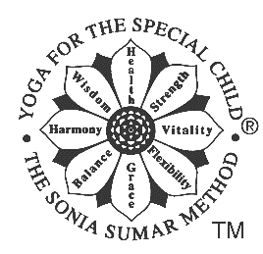

YOGA for the SPECIAL CHILD

It is important that you complete this form in order to assist me in making these one-to-one yoga therapy sessions safe and appropriate for your child/adolescent. All information will be kept strictly confidential.

Name of the yoga student

Date of Birth

Carer/Guardian Name (s)

Telephone numbers:

Email address:

What is the current diagnosis?

What are the physical symptoms of the disability/ condition?
(for example stiffness in left leg, or very floppy body and limbs)

Does your child have developmental delay? YES/N0
If so, please describe:

Are there any heart problems? YES/NO
If yes please state what these are:

Are there any hip problems or investigations for any hip problems?
YES/NO. If so, please detail:

Are there any problems with his/her spinal column? YES/NO
If Yes, please state what these are and in what area:

Does your child/adolescent suffer from convulsions? YES/NO
If Yes, please state when your last convulsion was and what the “trigger” was (if you know).

Has you’re your child/adolescent undergone surgery? YES/NO
If so, what for and what were the results?

Is he/she on any current medication? YES/NO
If so what for?

How would you the child/adolescent’s concentration, attention span and general awareness?

Yoga for the Special Child is a safe system; however, it is important that you keep me updated of any changes to this medical form. This is a hands-on therapy with complete respect to the student’s body but gentle adjustments may be necessary. By writing your name/signing this signing this form you agree to this

Signed……………………………………………………………. Date……/………/……… Jay Ehrlich www.yogababies.co.uk

